
Developed by Javi Prieto
(geese-bumps.itch.io)
For concurso BASIC 2025
Bytemaniacos
In a world devastated by a zombie apocalypse, you find yourself defending the last human city. You are humanity's final hope against the hordes of undead that threaten to wipe out life as we know it.
Your mission is to protect the city and its inhabitants for the designated time in each level. You must prevent the zombies from reaching the left side of the screen, where the entrance to the last bastion of human life is located.
Earn points for killing zombies, as well as for the resources and citizens you have left at the end of each level.
Will you be able to reach level 7 or surpass 3,000 points?

Controls

Game mode
- Space: Enter building mode
(game will pause itself for a while)
- F: Fire turrets

Building mode
- QAOP: Move cursor
TIP:
Turn the game into an arcade experience, setting your emulator to 200%, 300%, or even 500% speed. Dare yourself!
- Space: Exit building mode
- 0: Build brick
- 1, 2, 3: Build different kinds of turrets

Enemies

Blue zombie
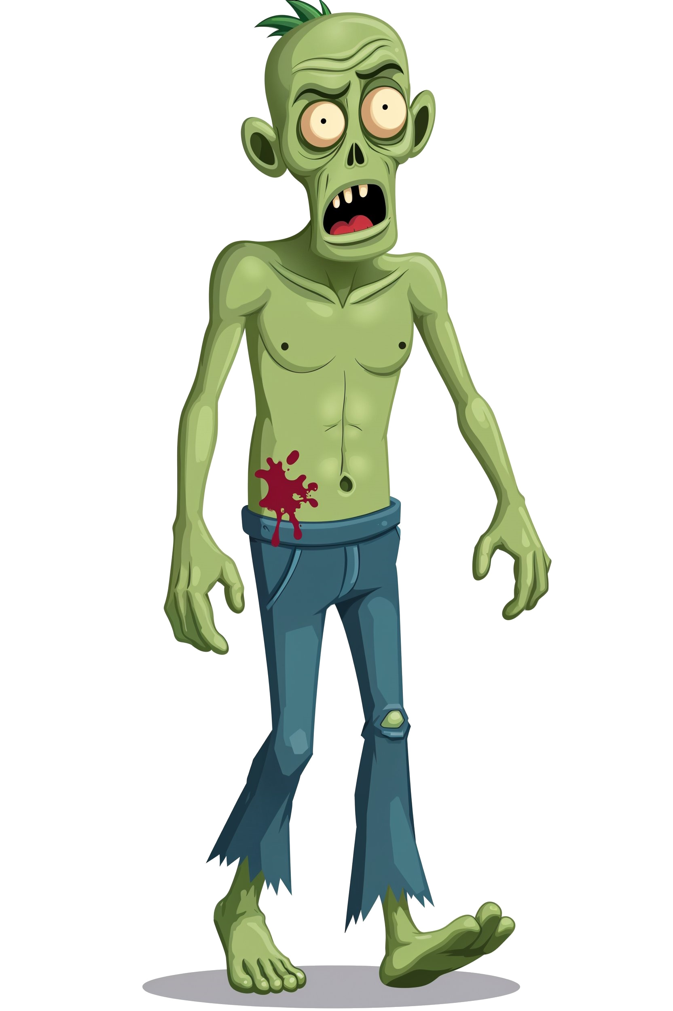
This is the standard enemy that appears from the beginning.
It moves at a normal speed and can withstand 3 hits before going down.
Wait until it gets closer to the left side before placing your defenses to plan your strategy better.

Red zombie

Appears starting from the second stage.
It moves faster but will die with a single hit.
If it's heading towards a citizen, you can let the citizen handle it instead of spending resources on a turret.

Purple zombie

This is the most dangerous of all.
Slow, but very tough, as it withstands 4 hits.
The green turret can kill it in one shot, and the purple turret can take it down in one turn if all shots hit.
You have time to go after it, but don’t let it get too close.

Defenses

You automatically gain resources over time, which you can use to build these defenses.

Bricks (key 0)

The most basic barrier to slow down zombies.
It has a low cost (2 resources) but little durability.
It won’t harm them, but it will buy you time to gather more resources or survive until the level ends.
Initially, a group of bricks will be placed in front of your citizens.

Red turret (key 1)
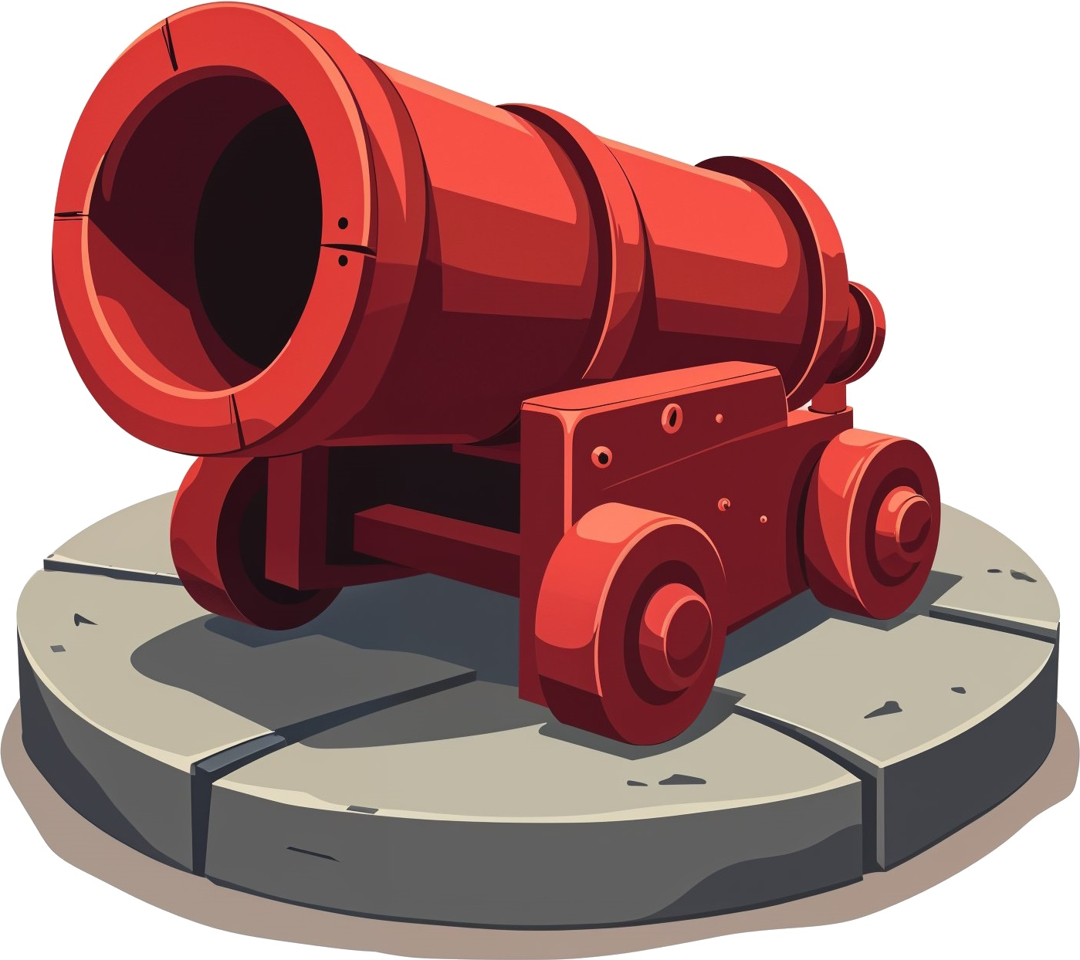
Fires up to three single shots before overheating and exploding.
Covers two vertical rows, so place it strategically to attack multiple zombies at once.
Costs 10 resources initially.

Purple turret (key 2)
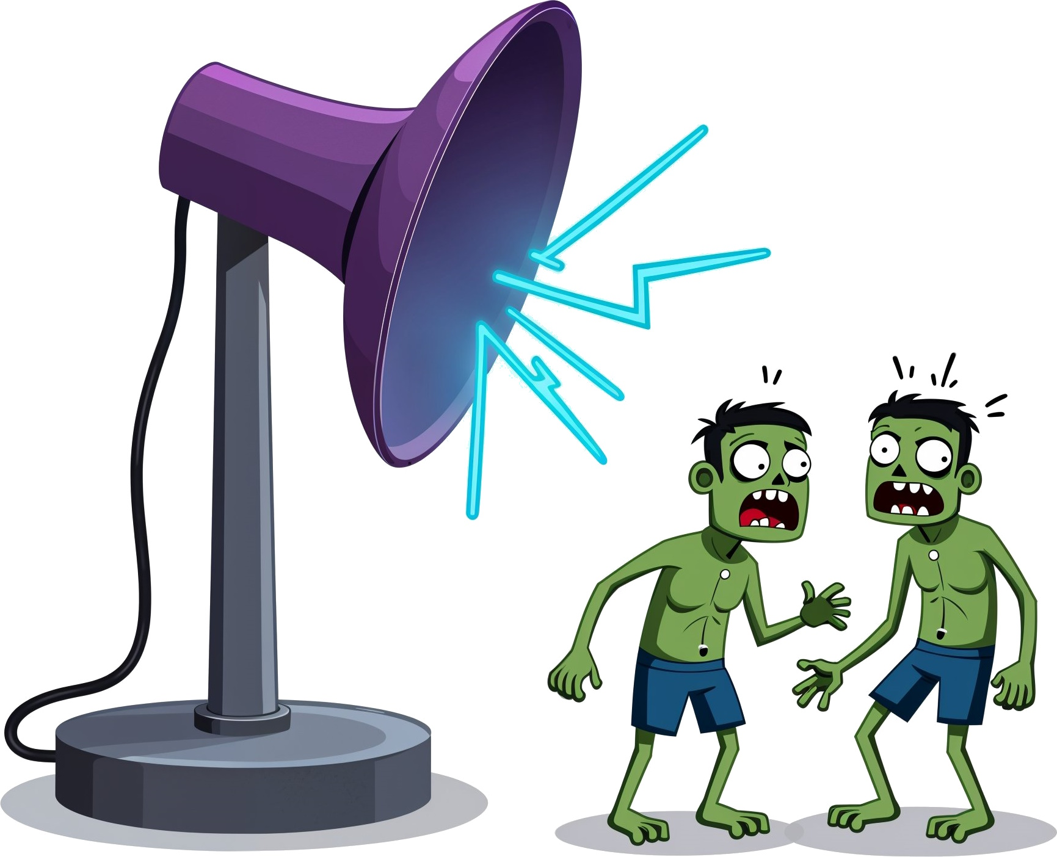
This powerful antenna fires up to three rays to damage zombies in nearby spaces.
Use it to attack groups of zombies that are not aligned.
Costs 15 resources until you reach the fourth level.
It can fire four times.

Green turret (key 3)

It can fire 3 powerful laser shots that will take down any enemy in a single hit.
They are your best asset against purple zombies or groups of enemies.
They cost 25 resources (until costs start to rise in level 4), so use them wisely to maximize each shot.

Citizens

A group of brave citizens has volunteered to be the last line of defense against the undead hordes.
When a zombie reaches them, they will do their best to slow it down while you gather resources to set up a defense.
Before they die, they will deal one point of damage to the zombies. Use that final effort wisely if you’ve been skillful enough to keep track of the damage dealt to each enemy.
You can’t generate them with resources: each level starts with a set number of citizens, but as you progress, fewer of them will be available to help you.

The Game Screen
In this image, you can see all the elements that make up the game interface:
C
T1
T2
Z1
Z2
Z3
T3
B
Thanks to Damien Guard for the “Spec5 Bold" typography for the ZX Spectrum
- Your defenses: Citizens (C), bricks (B), and turrets (T1, T2, T3).
The T3 turret is currently firing.
- Your enemies: Zombies of all types (Z1, Z2, and Z3).
- The scoreboard (Spanish version): The top line displays your controls, while the bottom line shows your available resources, remaining time to survive, and accumulated points.

When entering construction mode, the top line will remind you of your controls.
On the bottom line, you can see your available resources as well as the cost of each type of defense for that level.

Stay strong, brave general!
The last of our species are counting on you to survive.

